|  |  |  |  |  |  |
| --- | --- | --- | --- | --- | --- |
| Date | 22-Nov-22 | | | Tester Name | Shahabuddin Syed |
| Environment | Penfax - Test | | | Login used |  |
| Operating System | Windows | Version: | Update: | | |
| Software Used | Edge | Version: | Update: | | |
| Not Applicable | Version: | Update: | | |
| Release version | 22.4.1 | | | | |
| Title | Legal Order | | | | |
| Test Type | Regression | | | | |
| Test Scenario | Remove a Legal Order | | | | |
|  |  | | | | |
| Expected Results |  | | | | |
| Pass/Fail | Pass | | | JIRA# | N/A |

Describe your steps with screenshots:

Search for any member in the PEPP Plan

Click on their stakeholder ID Number

Select Stakeholder ID - 238237

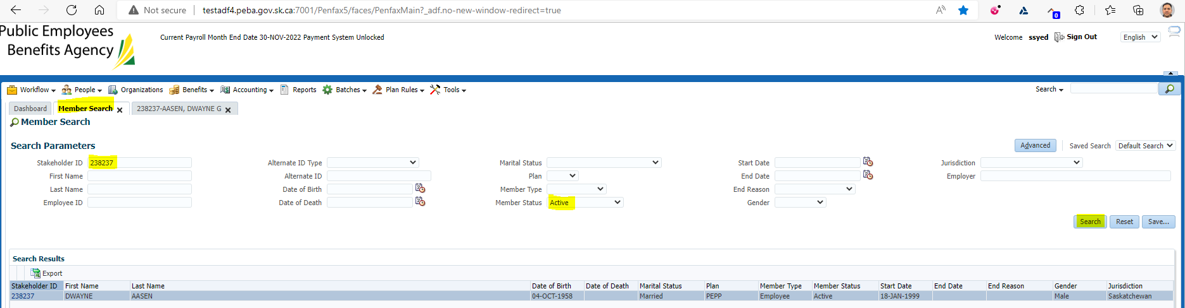

Click on Stakeholder ID - 238237

Click on Legal Orders

Under Legal Order click ADD

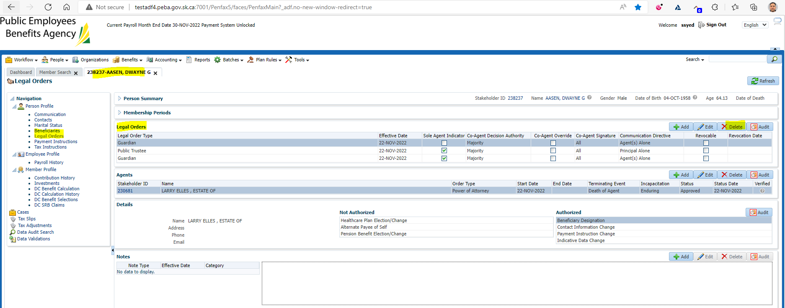

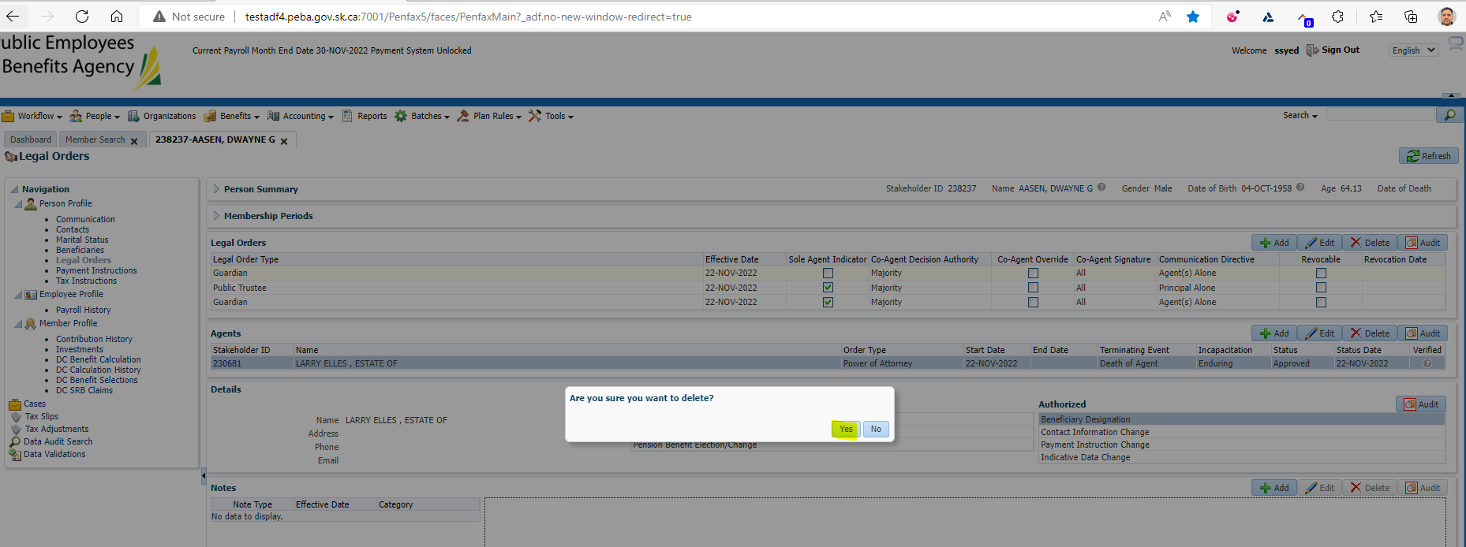

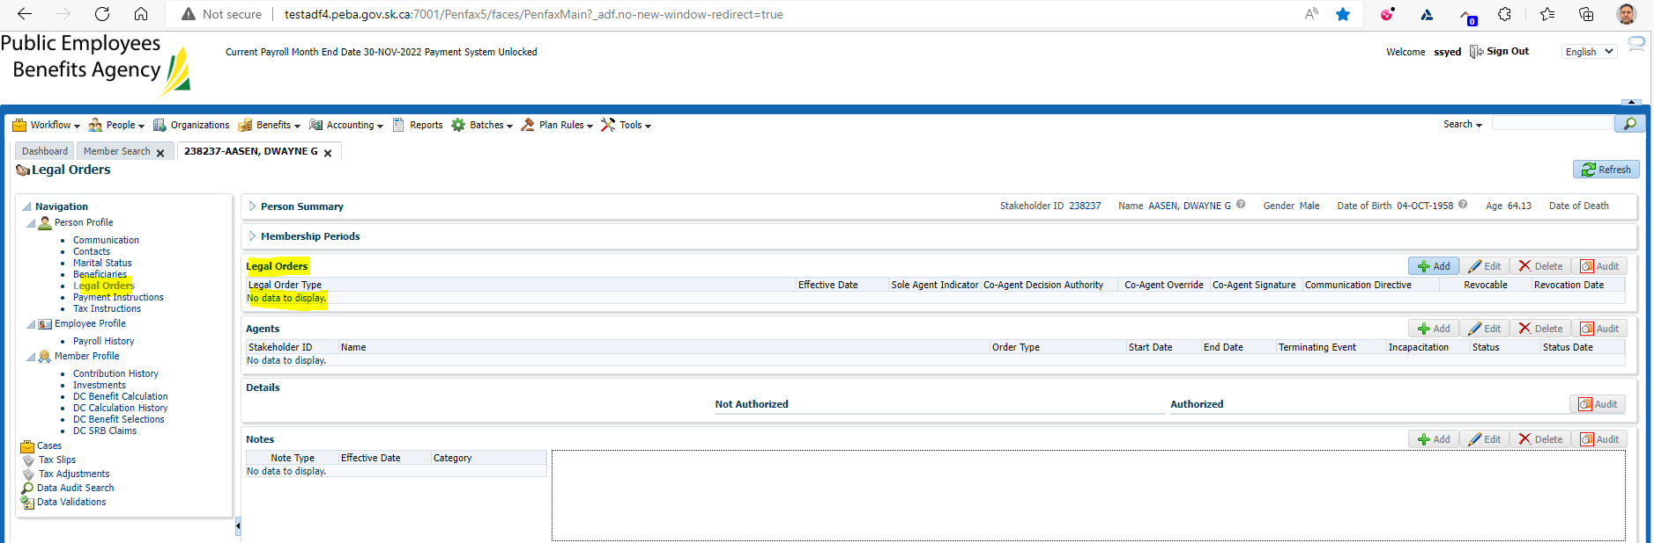

Result: “Pass”